3) A) Assuming that all power is being reflected at the paraboloid. Since all power is being reflected, then BDRF angle = 30 degrees
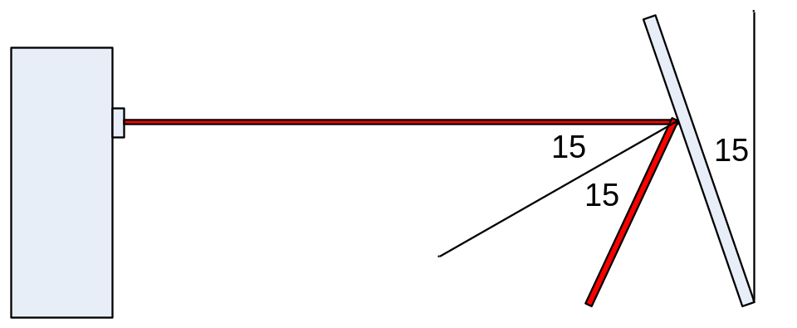
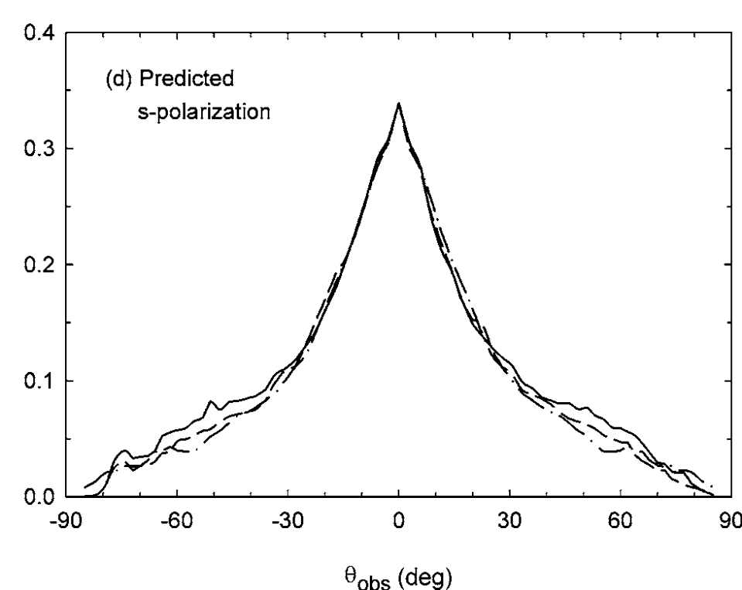
At a 30 degree the BRDF value is 0.1.

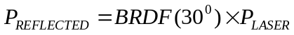

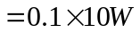

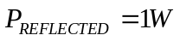

B)
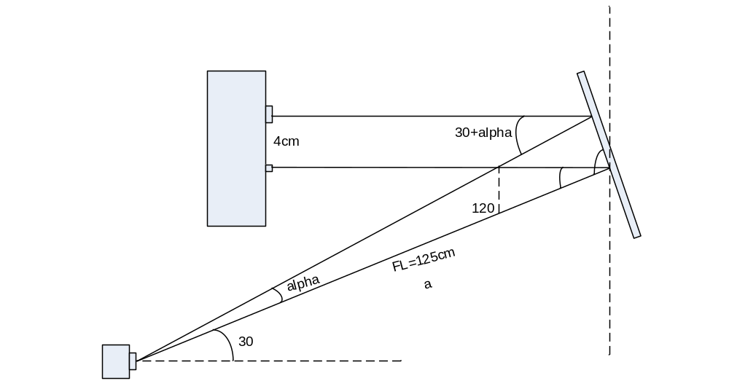

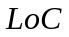

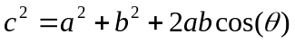

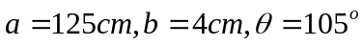

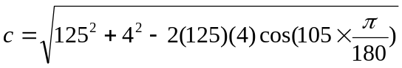

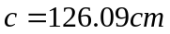

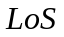

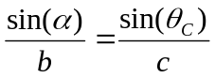

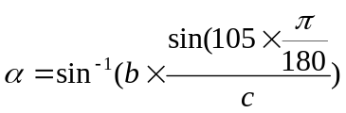

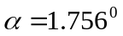

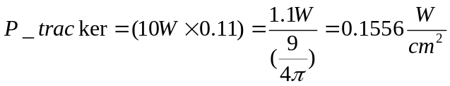
C)
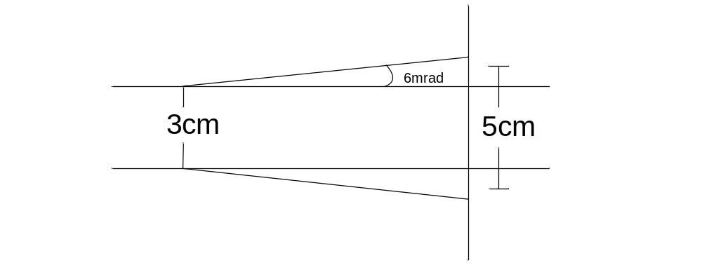

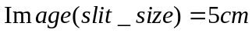

Since the field of view is greater than the image size, then YES – we can see the image.

D)

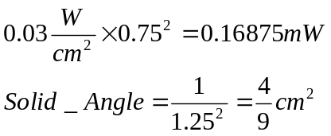

E)

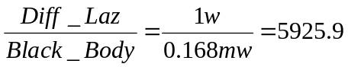

F)

